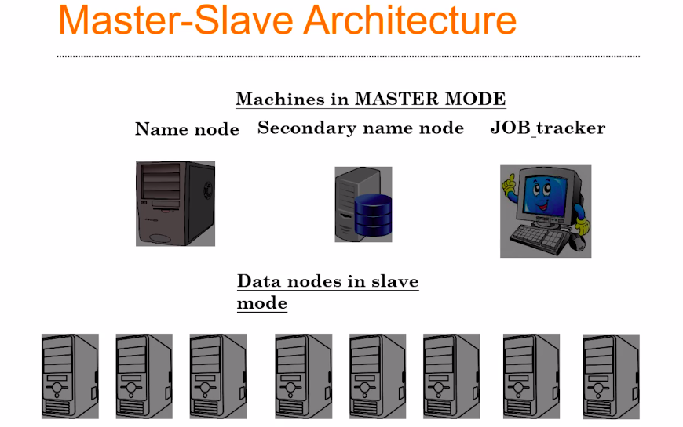

Let’s say you decided to have 10 machines into your cluster, in which 3 machines will always be working as masters. And the name of each server are Name Node, Secondary Name Node and a Job Tracker, these three are individual machine or individual servers in which Hadoop is running. These 3 machines will work in the master mode.

The remaining machines will work as a slave mode. Means, they will wait for instruction from the master, and these nodes are called as data nodes.

The Name Node, Secondary Node, Job Tracker, and Data Nodes will be interconnected by networking infrastructure, means they are not going to be interconnected by wifi routers, but by physical Ethernet cables or Fiber Optics for a high performance.

